* Customer_data
* Internet_data
* churn_data

Q-1: Use select to fetch the first 10 rows from the table “churn”.

Q-2: Use select to fetch the first 10 rows from customer table in the following format:

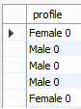

Hint: Use concat with “gender” and “seniorcitizen”

Q-3: Use select and where clause to filter top-10 rows, only those customers who didn’t churned.

Hint: churn = ‘No’

Q-4: Find the average monthly charges for non-churn customers. Hint: Use table churn and avg() command

Q-5: Find the average monthly charges for churn customers and round the answer to two decimal places also name the resultant column as “Avg_Churn”. Hint: Use table churn and avg() command

Q-6: Find the count of churn and non-churn customers.

Q-7: Find the count of male and females customers.

Q-8: Find the count of customers who are male, have a partner and no dependents.

Q-9: The company is trying to invest 10% of the total charges that were gained by non-churn customers to acquire more customers. Find the 10% of the sum of the total charges for the non-churn customers.

Q-10: Order the churn data in descending order and find the customer with the maximum monthly charges.

Q-11: Order the churn data in descending order and find the customer with the maximum monthly charges and maximum tenure.

Q-12: Using not-in functionality filters those customers who do not use DSL or Fiber Optics as an Internet Service.

Q-13: Find those non-churn customers whose monthly charges are greater than 100.

Q-14: Find those non-churn customers whose monthly charges are between 100 and 150.

Q-15: Find the customer with 3rd highest monthly charges.

Q-16: Find the unique categories under the Payment method column under the churn column.

Q-17: According to the company, golden customers are those customers who have completed 50-70 months with the company and have not churned. Find the count of such customers.

| id | monthlycharges |
| --- | --- |
| 2 | 10 |
| 5 | 11 |
| 6 | 15 |
| **8** | **20** |
| 11 | 45 |
| 7 | 77 |
| 1 | 5 |

Limit 3, 4

Offset = 3

Rows = 4

Limit 2,1

**Session-3(Module-4)**

Q-1: Find the percentage of churn and non-churn customers. Use table: **churn_data**

Q-2: Find the percentage of monthly changes paid by Males and Females. Use table: **churn_data**, customer_data. Hint: Use Inner Join.

Q-3: Find the count of employees that have a salary greater than the average salary of department_id 30. Use table: employees_data

Q-4: Find the count of employees that have a salary greater than the average salary of ‘shipping’ department and doesn't include those who are having job_title as ‘president’

Use table: employees_data, jobs_data, department_data

Q-5: Generate the below resultant table output using self join: Use table: churn_data

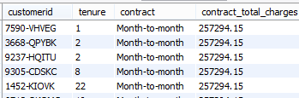

Q-6: Find the average salary of employees who work at ‘Executive’ Department. Use table: Employees_data, Departments_data

Q-7: Filter all the managers from the data with all the fields. Use data: Employees_data

Q-8: Generate the following resultant table output: Use data: Employees_data

Hint: Results are sorted in descending order of the salary and have data only for managers with hire year extracted from hire_date

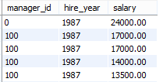

Q-9: Filter all those employees who work at ‘US’. Use data employees_data, departments_data, locations_data. Hint: use subquery.

Q-10: Generate the following resultant table output: Use data: Employees_data, job_data

Salary_range = max_salary-min_salary

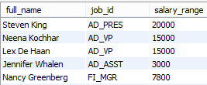

Q-11: Generate the following resultant table output: Use data: employees_data, job_history

Tenure = year(end_date)-year(start_date)

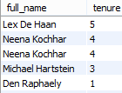

Q-12: Find the region wise average salary. Use tables: employees_data, departments_data, locations_data, region_data

Q-13: Create a new database in your MySql workbench and name it as “sql_session”

Q-14: Create a new table named “employee” with the following columns and constraints:

* Id : int not null
* First_name: varchar(10)
* Last_name: varchar(10)
* Salary: float
* Primary key: id

Q-15: Insert the following data into the employee table as created in the last question.

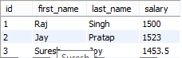

Q-16: Update the salary for employee=3 and make it to 1553.5

Q-17: Add a new field manager to the employee table with the default value as 0.

Q-18: Delete the records where salary is greater than 1550.

Q-19: Drop the table employee and drop the database.